* DNS maitre

# Apt-get update

# Apt-get upgrade

# Apt-get install Bind9

# Gedit /etc/hostname

Maitre

# Gedit /etc/hosts

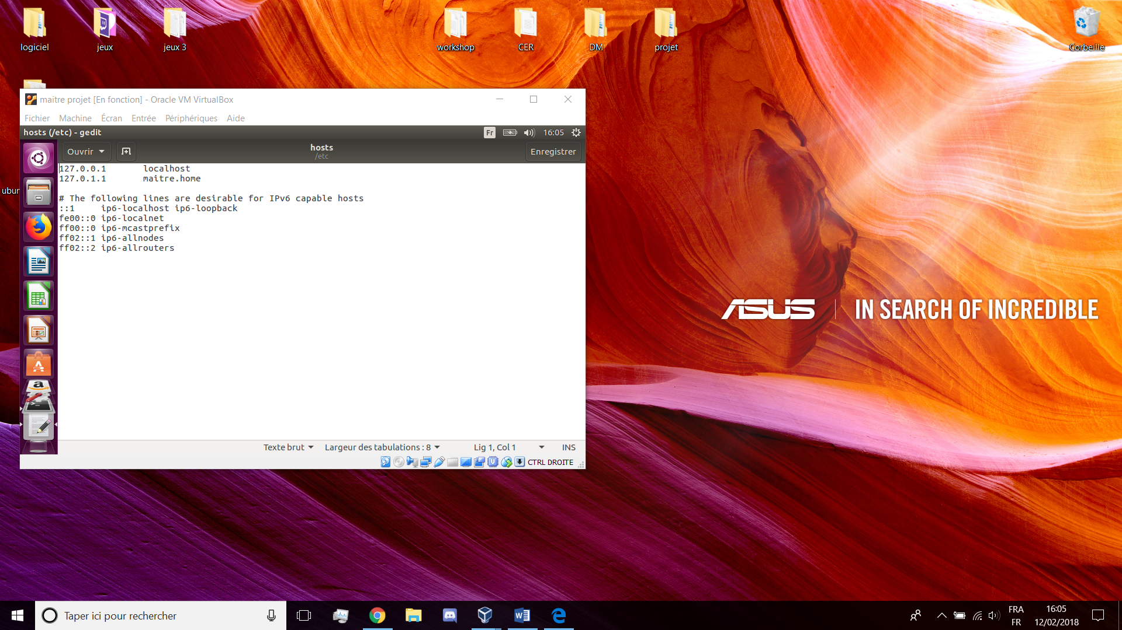

# Gedit /etc/bind/named.conf.options

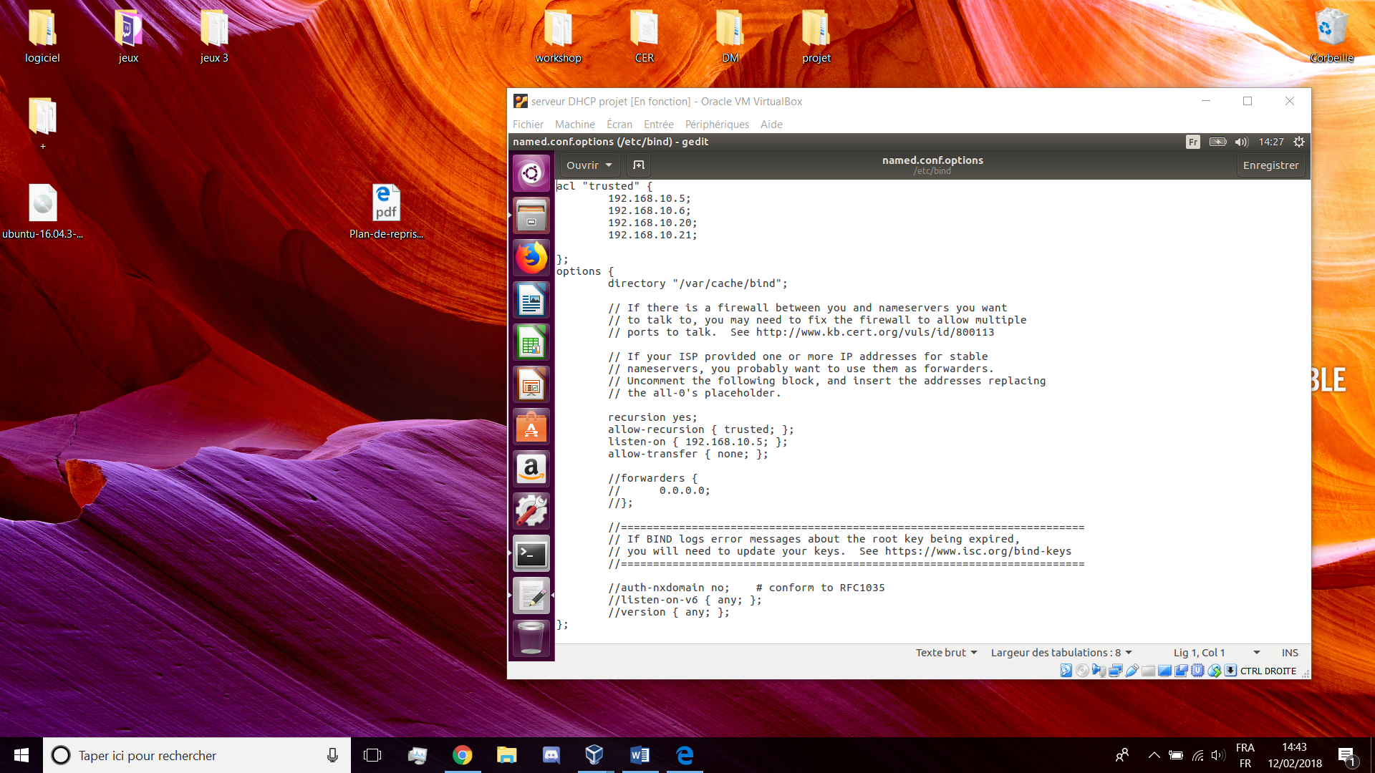

# Gedit /etc/bind/named.conf.local

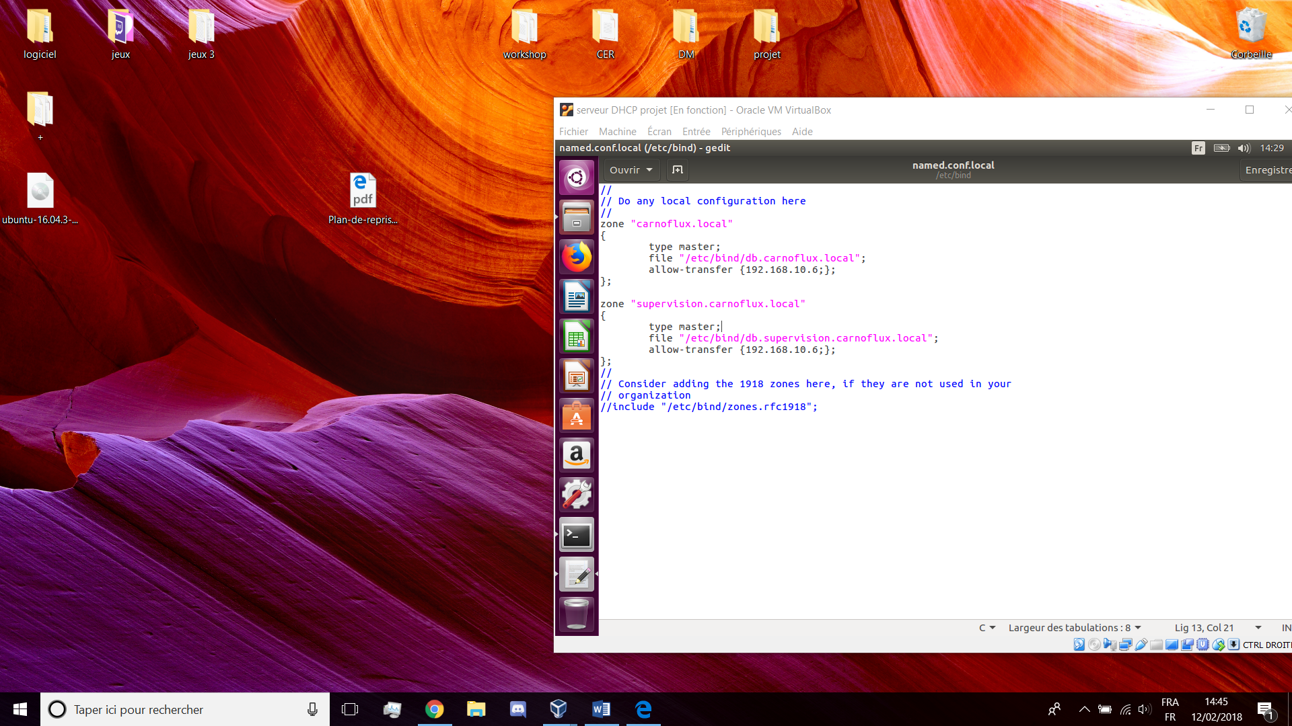

# Gedit /etc/bind/carnoflux.local

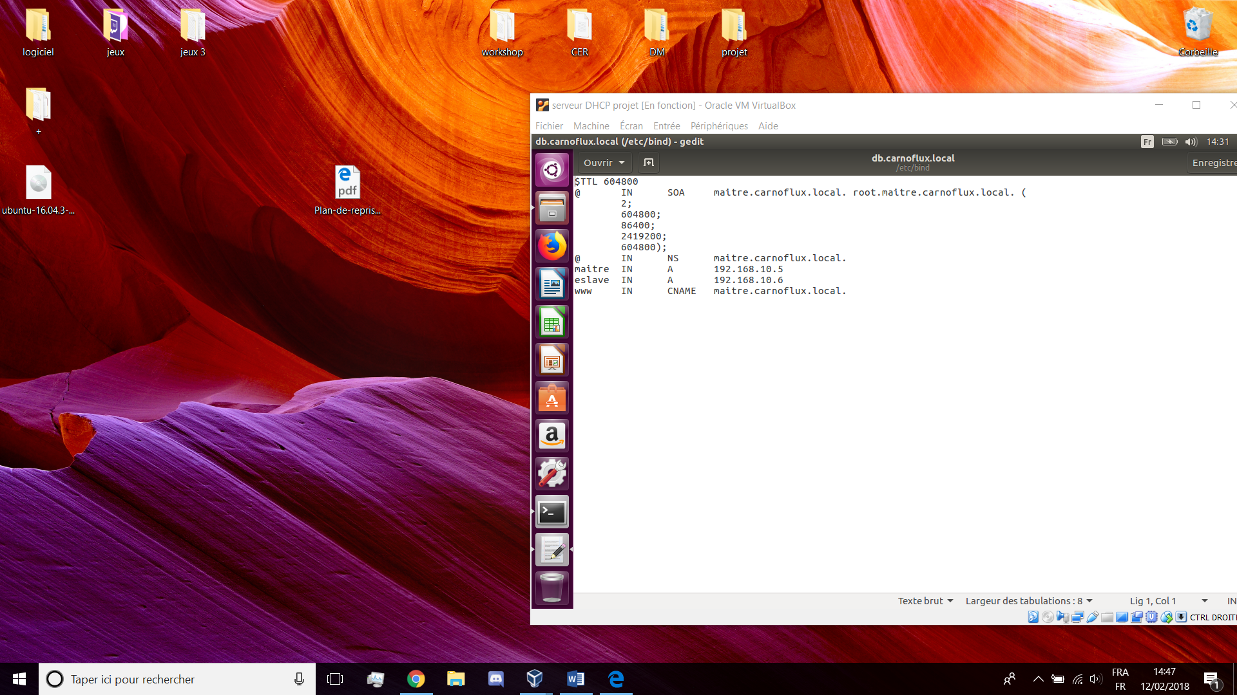

# Gedit /etc/bind/supervision.carnoflux.local

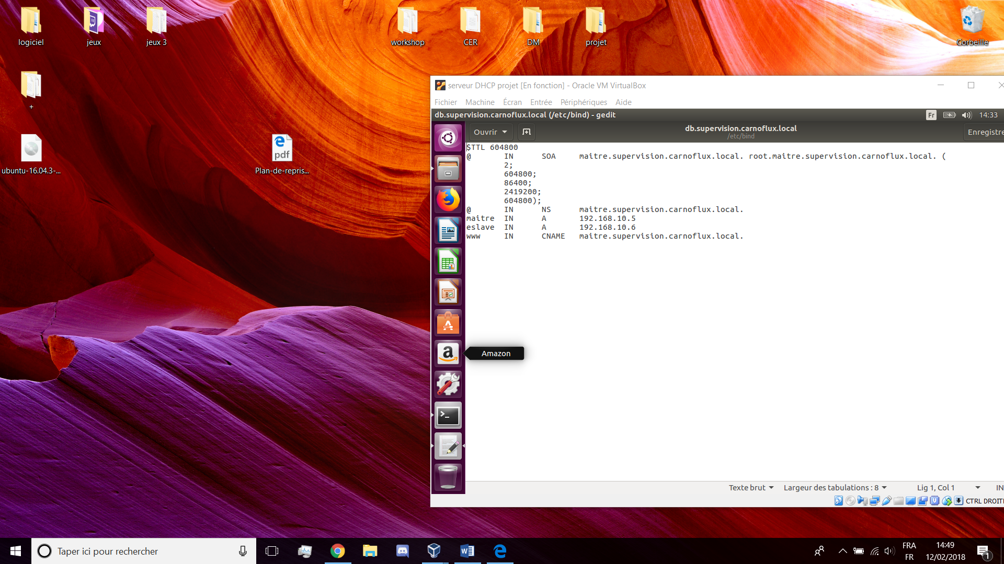

# Named-checkconf -z

* DNS esclave

Différence :

# Gedit /etc/hostname

Eslcave

# Gedit /etc/hosts

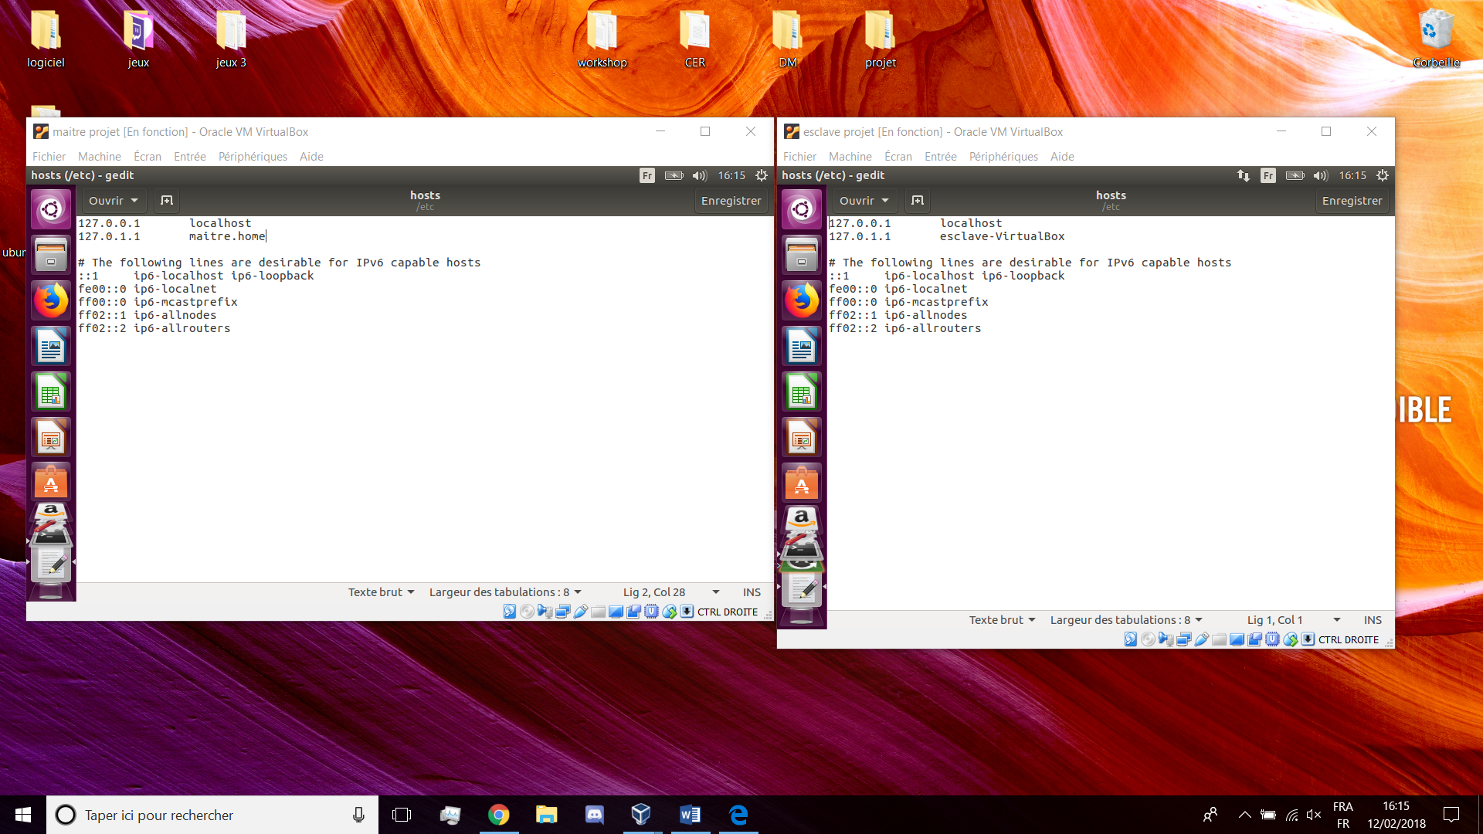

# Gedit /ect/bind/named.conf.local

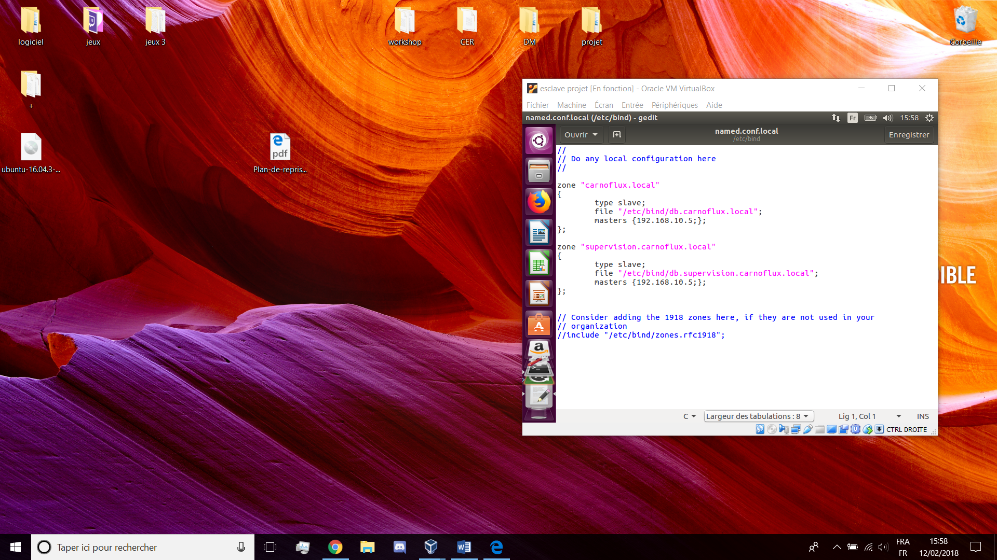

* DHCP

# Apt-get update

# Apt-get upgarde

# Apt-get install isc-dhcp-server

# Gedit /etc/default/isc-dhcp-server

# 

# Gedit /etc/dhcp/dhcpd.conf

# 

# /etc/init.d/isc-dhcp-server start